RETAIL SALES PERFORMMANCE ANALYSIS

1.Identify missing values and duplicates in the Sales dataset. What cleaning steps are required?
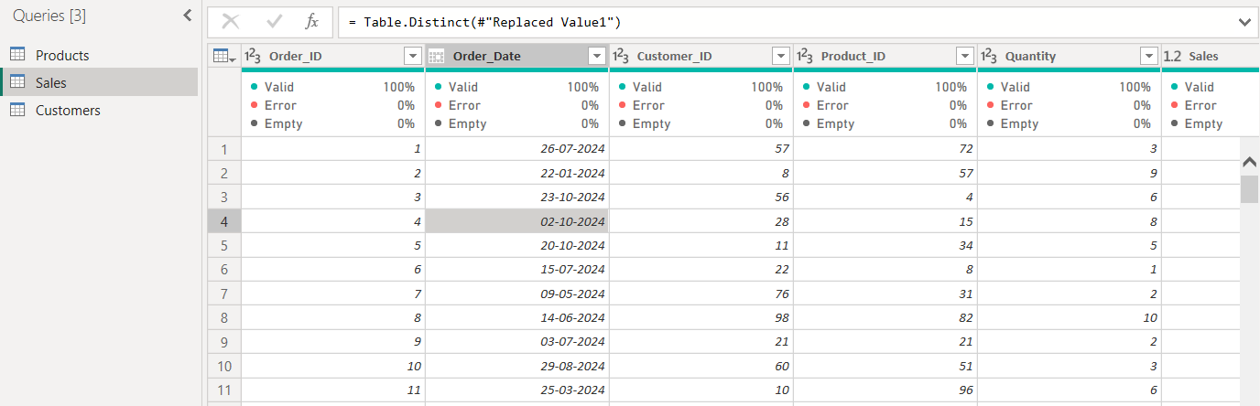
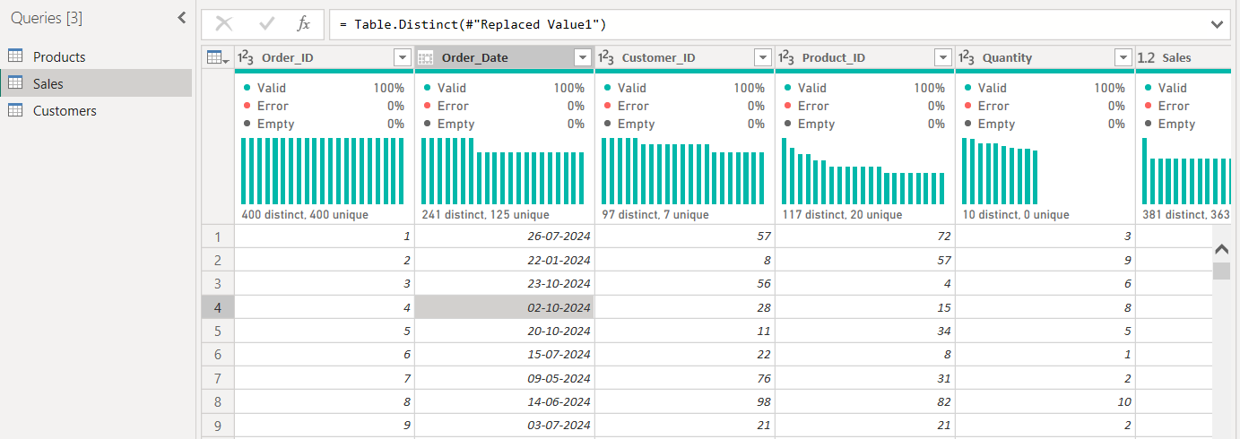
Data cleaning improved data quality by removing duplicates, handling missing values, and ensuring correct data types. This ensures accurate calculations, reliable insights, and better decision-making in the Power BI dashboard.

2.Perform univariate analysis on Sales and Profit. What distribution patterns do you observe?
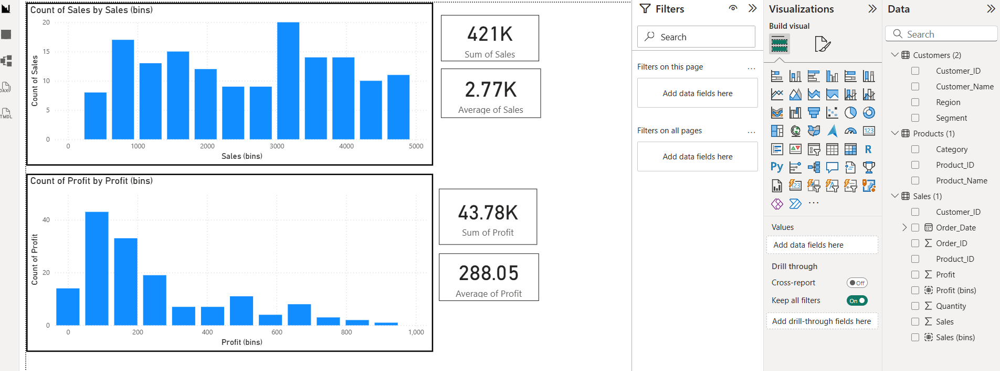

Univariate analysis of Sales shows a right-skewed distribution where most transactions are of low to moderate value, with few high-value outliers. Profit distribution reveals both gains and losses, indicating variability and presence of loss-making transactions. Histograms and summary statistics in Power BI help understand data spread, central tendency, and outliers effectively.

3.Which product categories contribute the highest revenue and profit?
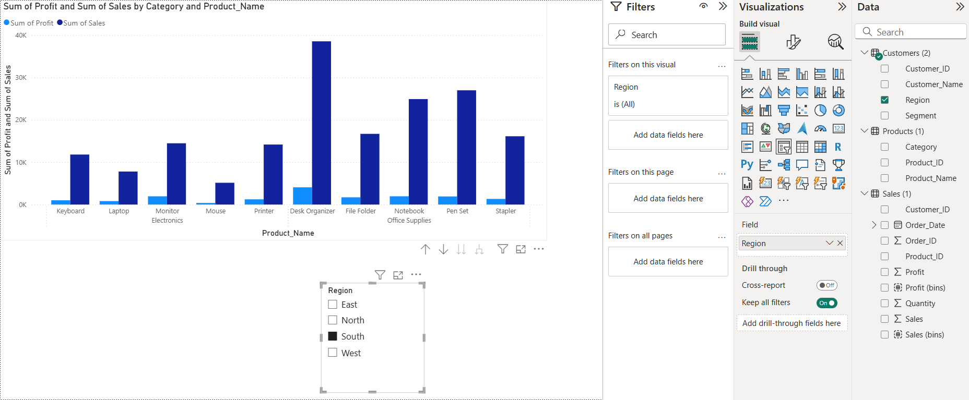
The chart shows the sum of sales and profit by product for the selected region (South). Sales are significantly higher than profit for all products, indicating moderate profit margins. The Desk Organizer generates the highest sales, followed by Pen Set and Notebook, while products like Mouse and Laptop contribute comparatively lower sales. Profit follows a similar pattern but remains much smaller than sales, suggesting that some high-revenue products may still have lower margins. This analysis helps identify top-performing products and those that may require pricing or cost optimization.

4.How does sales performance vary across regions?
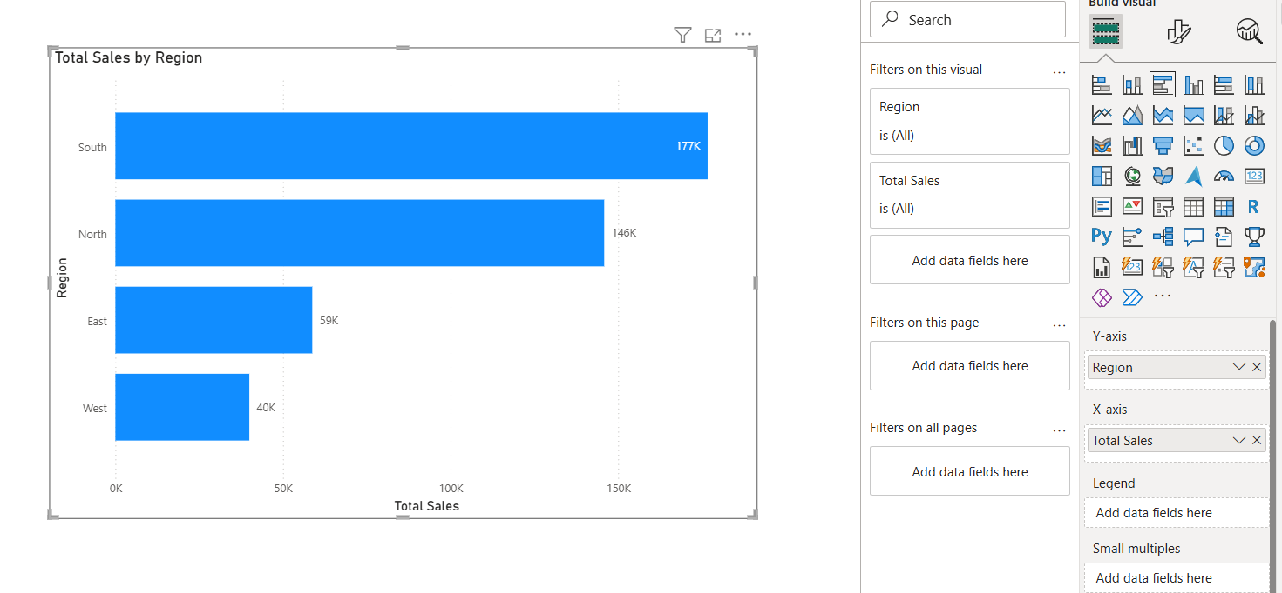
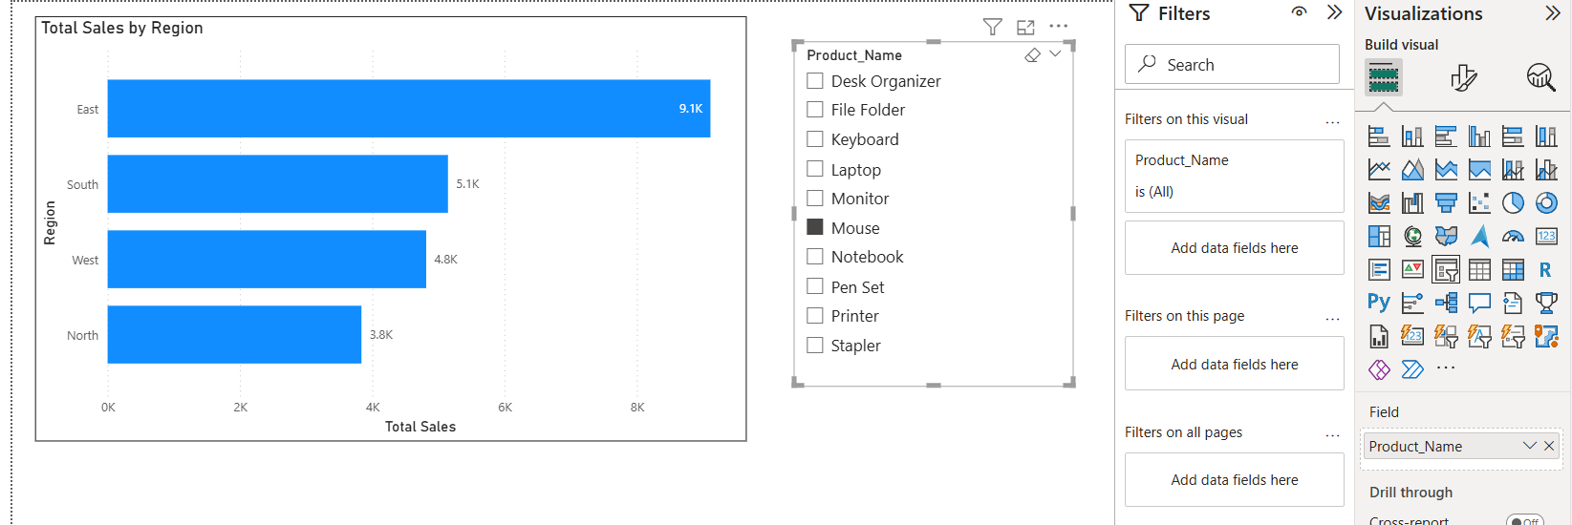
Sales performance varies across regions, with some regions generating higher revenue than others. Regions with high sales but relatively lower profits indicate possible issues in pricing, discounts, or operational costs.

5.Create a star schema using Sales, Customer, and Product tables. Why is this model effective?
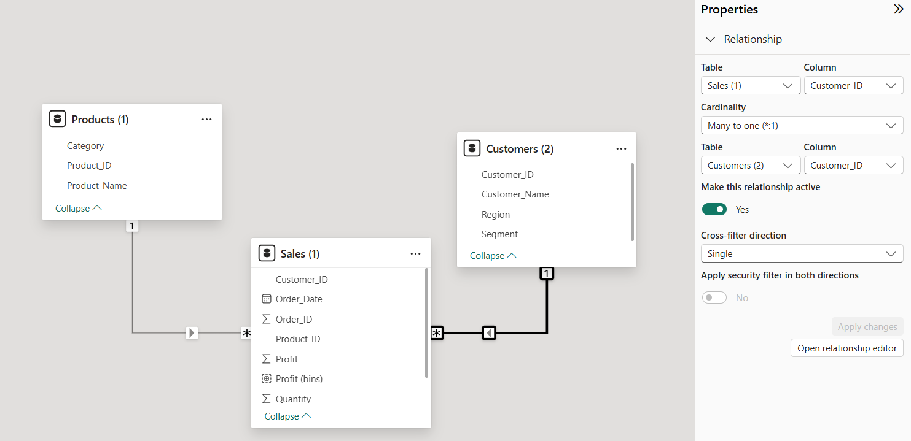
STAR SCHEMA :
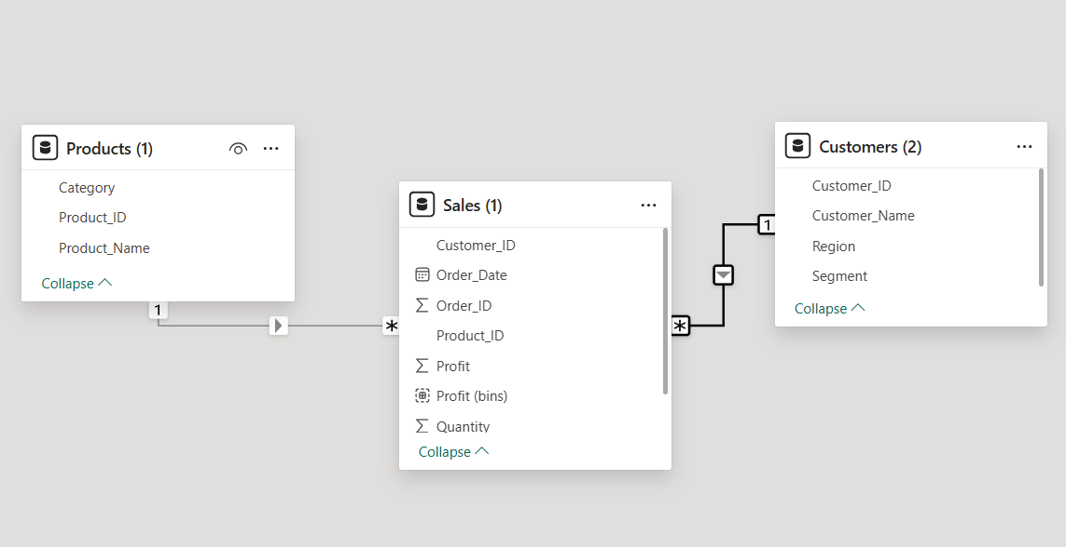
The star schema is effective because it improves query performance, simplifies data modeling, and makes reporting easier. The fact table stores transactional data, while dimension tables store descriptive attributes such as product category and customer region.

6.Write a DAX measure to calculate Total Sales and Total Profit.

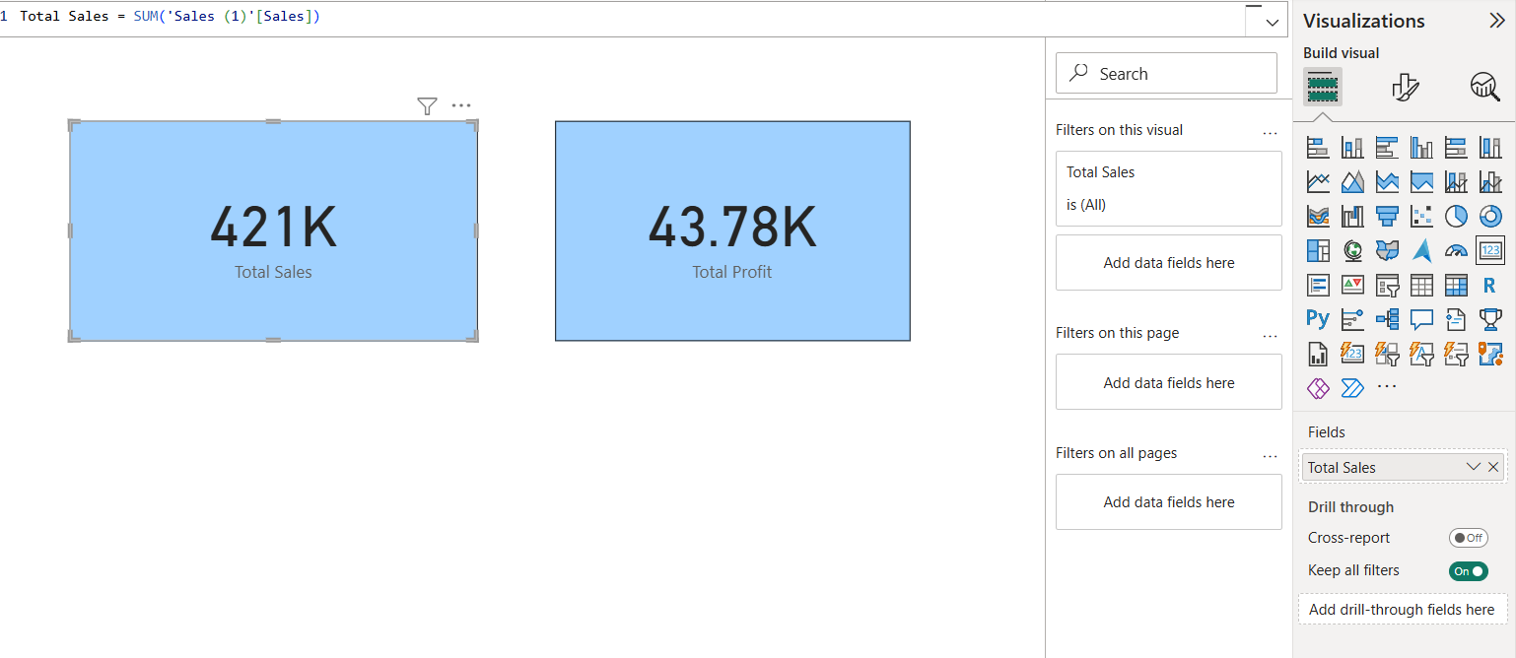
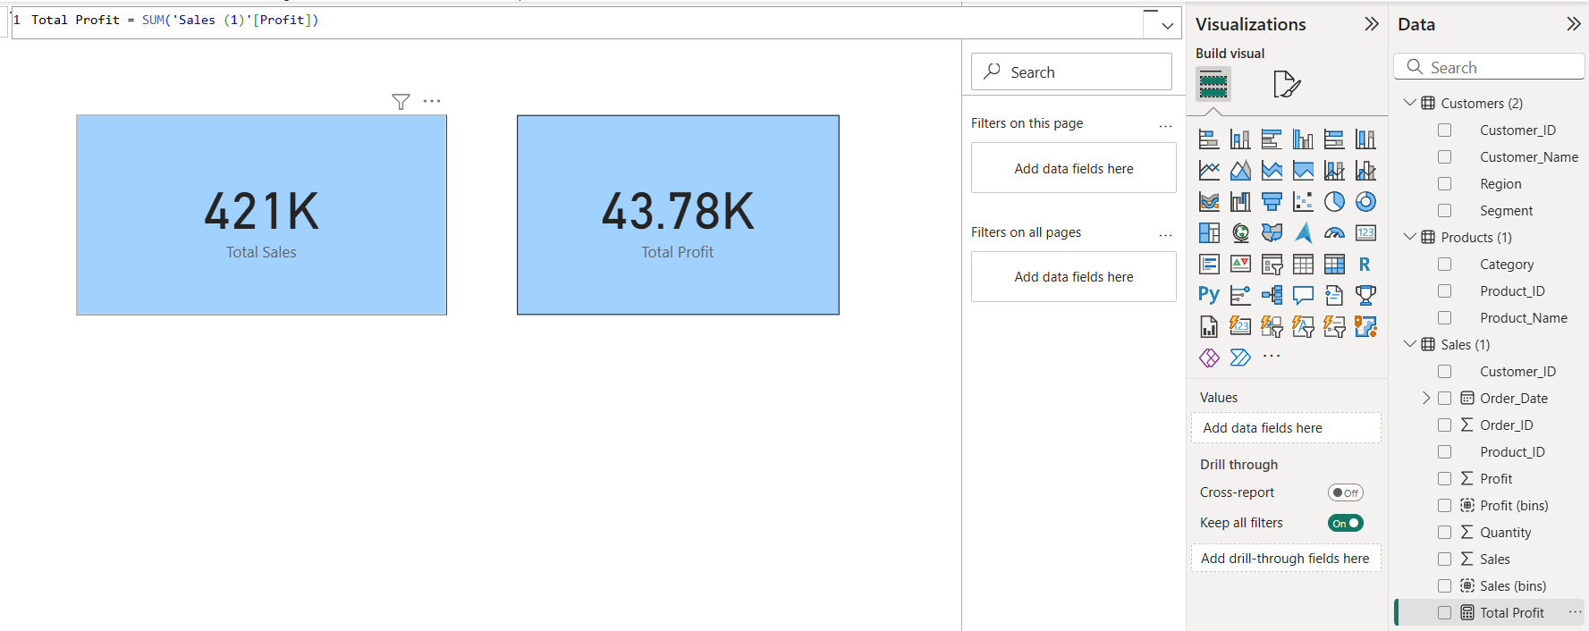
Total Sales and Total Profit are calculated using DAX measures by applying the SUM function on the Sales and Profit columns. These measures help summarize revenue and profitability for analysis and dashboard reporting.

7.Calculate Profit Margin (%) using DAX and identify low-margin products.
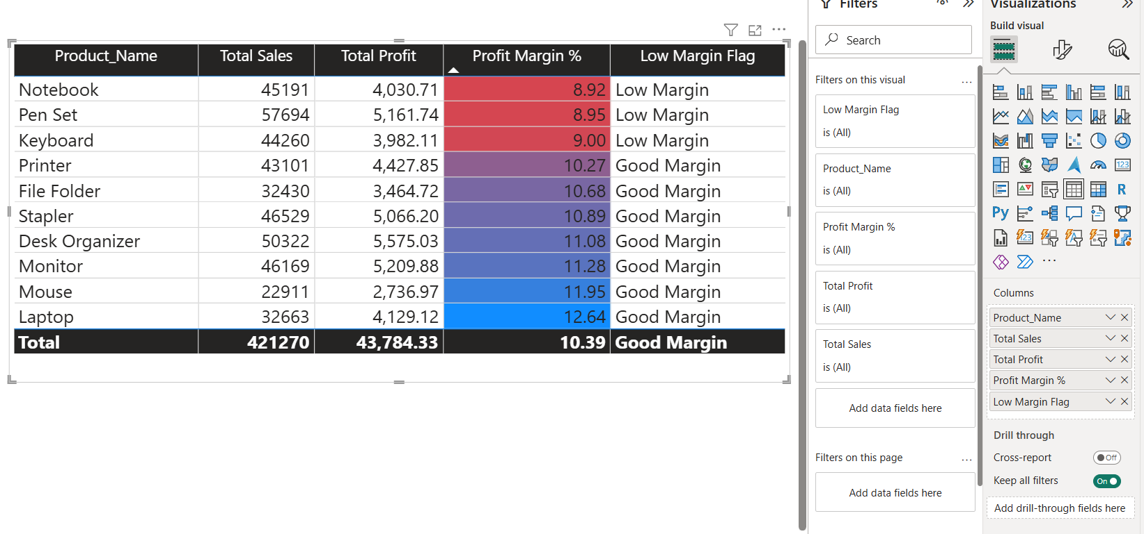
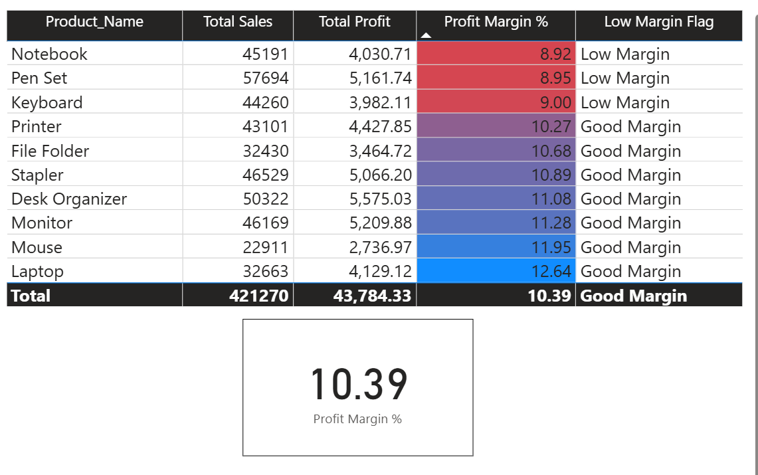
Profit Margin (%) was calculated using a DAX measure by dividing Total Profit by Total Sales. Products with lower margin percentages were identified using a sorted table and conditional formatting, helping highlight items that may require pricing revision or promotional strategies.
8.Design a dashboard to show regional and category-wise performance.
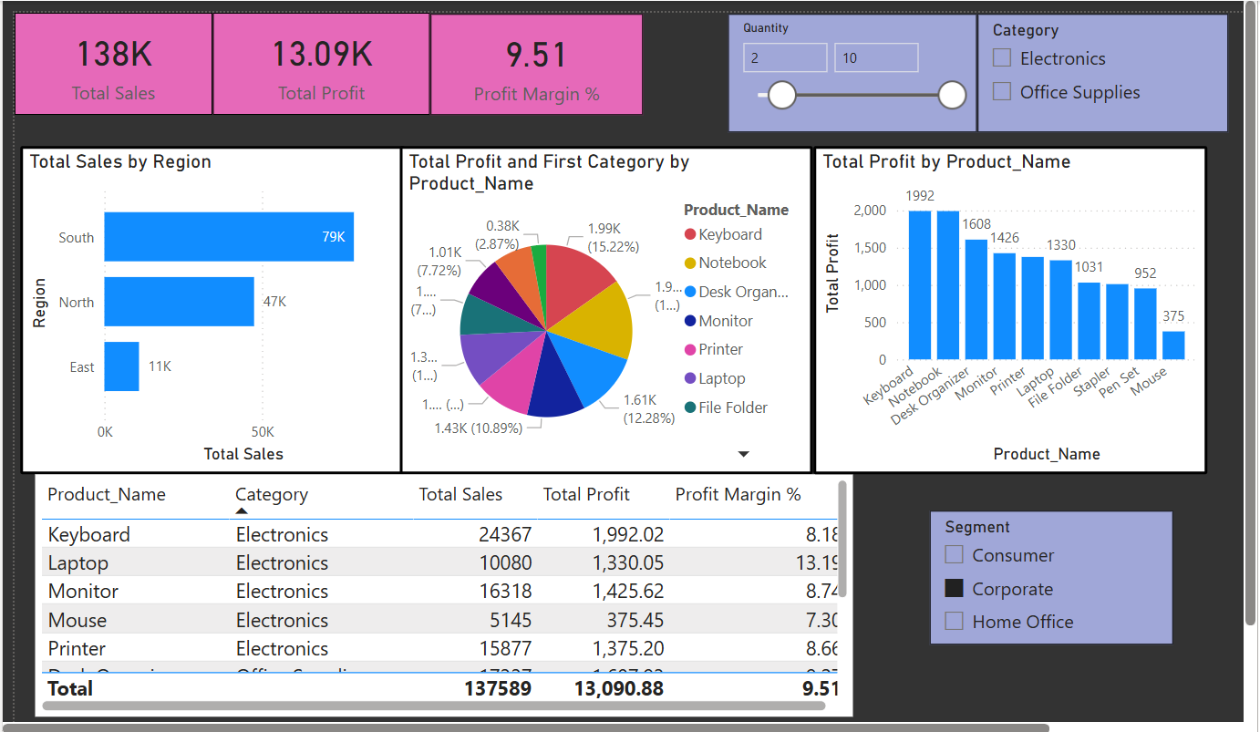

The dashboard was designed to visualize regional and category-wise performance using KPI cards, bar charts, and slicers. It enables management to compare revenue and profitability across regions and product categories, helping identify performance gaps and support decision-making.

9.Which products should be discontinued or promoted based on analysis?
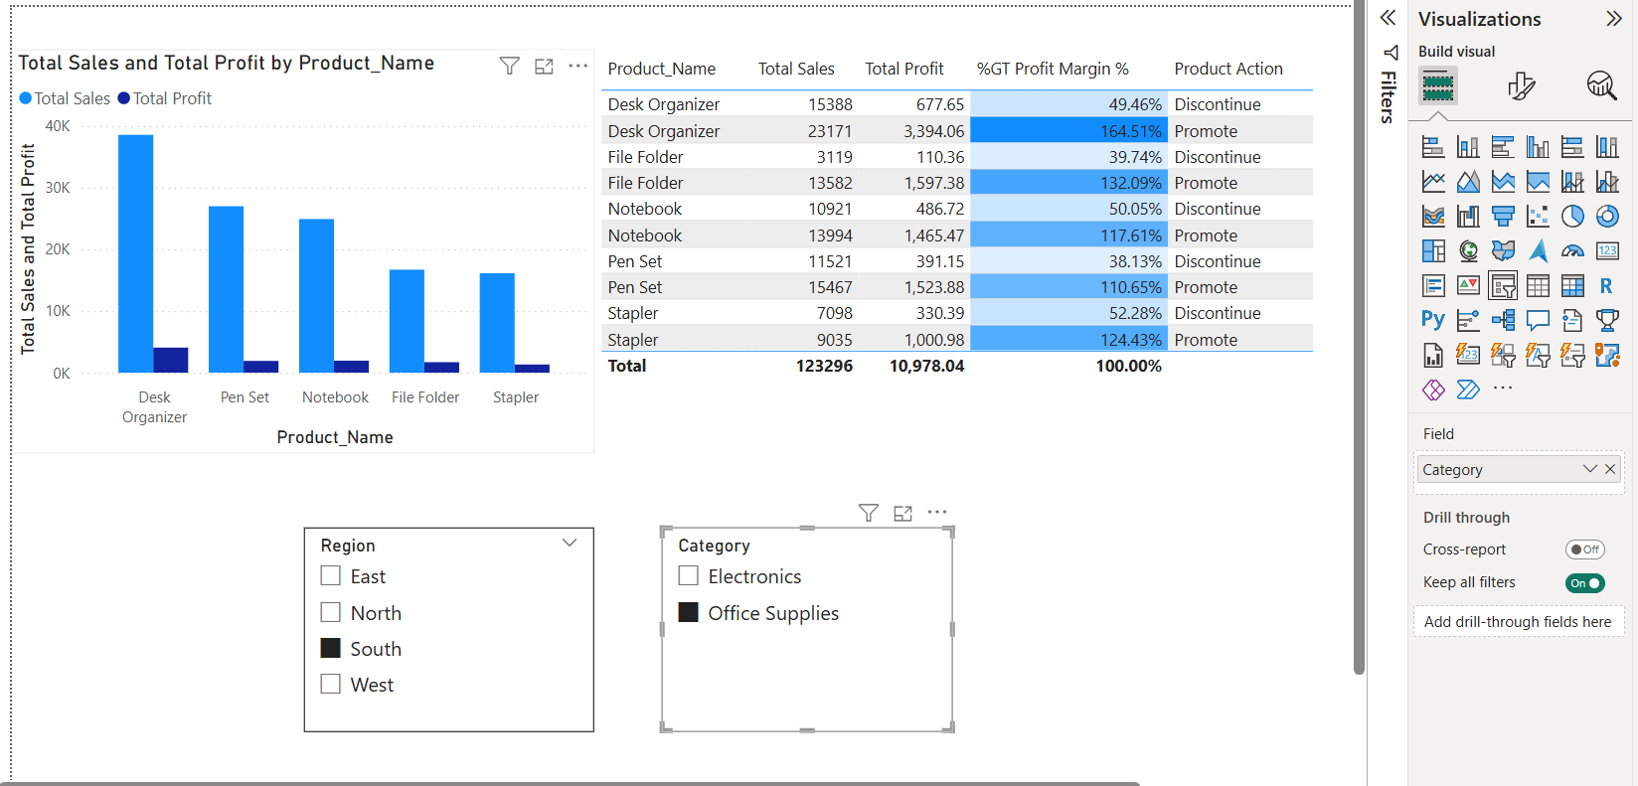
In Power BI, products are evaluated using product-wise sales, profit, and profit margin visuals. Clustered column charts and tables with DAX measures help identify high-performing products for promotion and low-margin products for discontinuation or repricing. Filters and slicers support region-wise decision-making.

